# Chapter 17: HTML5 Layout

-Traditional HTML layouts

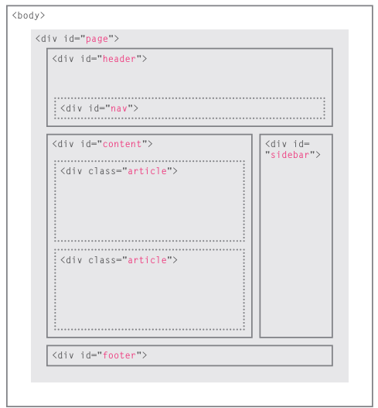

-New HTML5 layout elements:

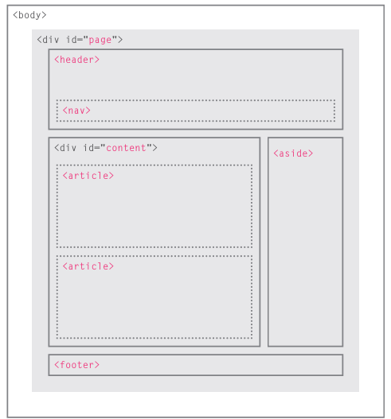

-Headers & footers: <header> <footer>

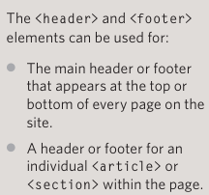

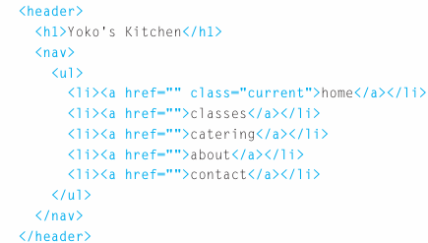

-Navigation <nav>: contain the major navigational blocks on site such as primary site navigation

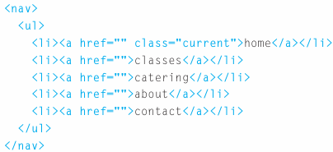

-Articles <article>: a container for any section of page that could stand alone and potentially be syndicated. This could be an individual article or blog entry, a comment or forum post, or any other independent piece of content.

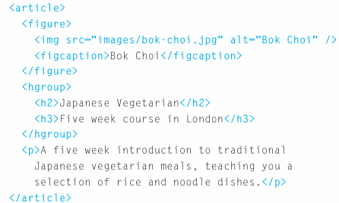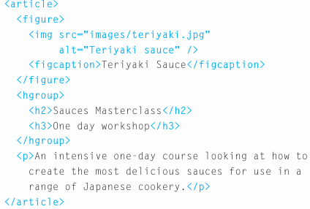

-Asides <aside>:

+When <aside> is inside <article>, it should contain information that is related to article but not essential to its overall meaning.

+When <aside> is outside <article>, it acts as a container for content that is related to entire page.

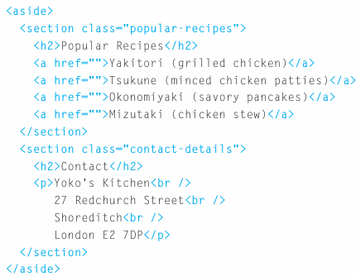

-Section <section>: group related content together, and each section would have its own heading. It may contain several distinct <article>.

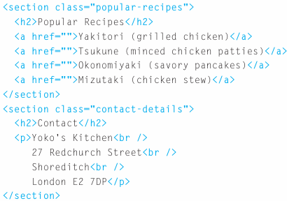

-Heading groups <hgroup>: group together a set of one or more <h1> through <h6> so that they are treated as one single heading.

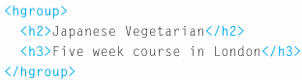

-Figures <figure> <figcaption>

+<figure> contain any content that is referenced from the main flow of an article: images, videos, graphs, diagrams, code samples, text that supports the main body of an article.

+<figure> should also contain a <figcation> providing a text decription for the content of <figure>

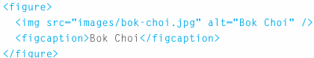

-Sectioning elements <div>: group together related elements. Where there is not suitable element to group a set of elements, <div> still be used.

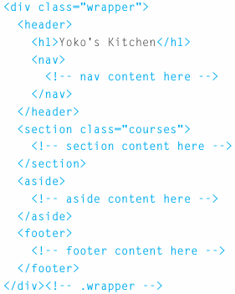

-Linking around block-level elements: HTML5 allows authors to place an <a> around a block level element that contains child element. This allows to turn an entire block into a link

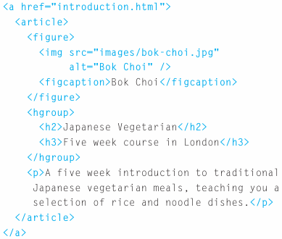

-Helping older browsers understand

+Older browsers that don’t know new HTML5 elements will treat them as inline elements. You should include CSS line on left which states which new elements should be referenced as block element

+To style elements using earlier versions of IE, use JS known as HTML5 shiv or HTML5 shim. Don’t need to understand JS to use it. Just link to a copy that Google hosts on its servers. It should be placed inside conditional comment which checks if the browser version is less than IE9.

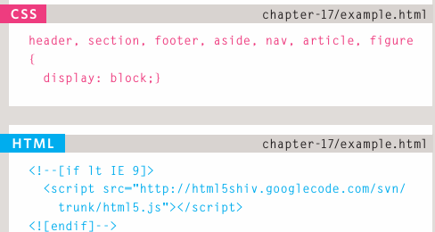

-Summary

+The new HTML5 elements indicate the purpose of different parts of a web page and help to describe its structure

+The new elements provide clearer code (compared with using multiple <div> elements)

+Older browsers that don’t understand HTML5 elements need to be told which elements are block-level elements.

+To make HTML5 elements work in IE8 (and older versions of IE), extra JS is needed, which is available free from Google.

# Chapter 18: Process & Design

-Who is the site for?

+Every website should be designed for the target audience-not just yourself or the site owner. It’s therefore very important to understand who your target audience is.

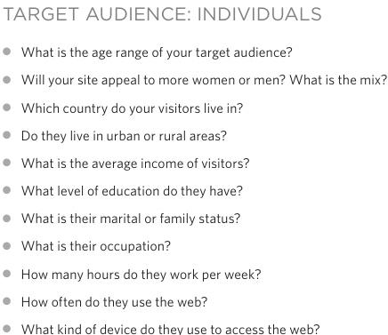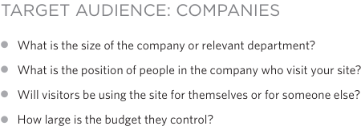

+Invent some fictional visitors from your typical target audience. They can influence design decisions from color palettes to level of detail in description

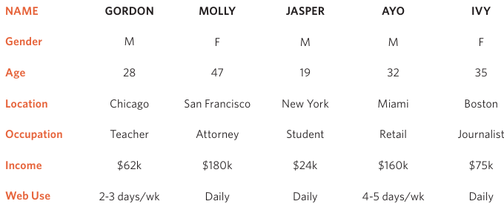

-Why people visit your website

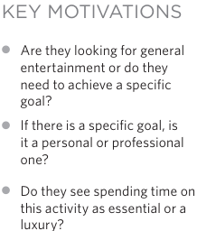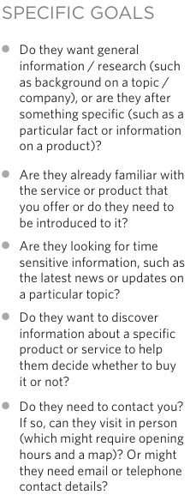

-What your visitors are trying to achieve

+It’s likely that you will be able to list every reason why someone visits your site but you are looking for key tasks and motivations. This information can help guide your site designs.

+1st you want to create a list of reasons why people would be coming to your site. You can then assign the list of tasks to the fictional visitors.

-What information your visitors need

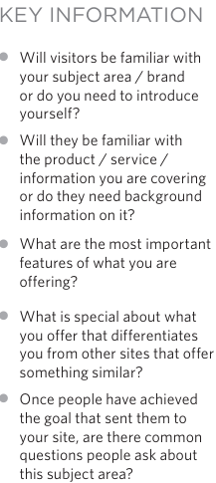

-How often people will visit your site:

+Some sites benefit from being updated more frequently than others. Some information (such as news) may be constantly changing, while other content remains static.

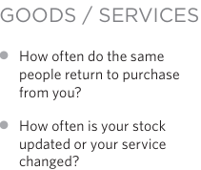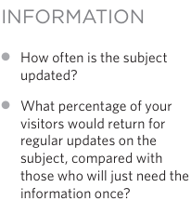

-Site maps: show how those pages can be grouped. You can use a technique card sorting: place each piece of information that a visitor might need to know on a separate piece of paper and then organizing the related information into groups.

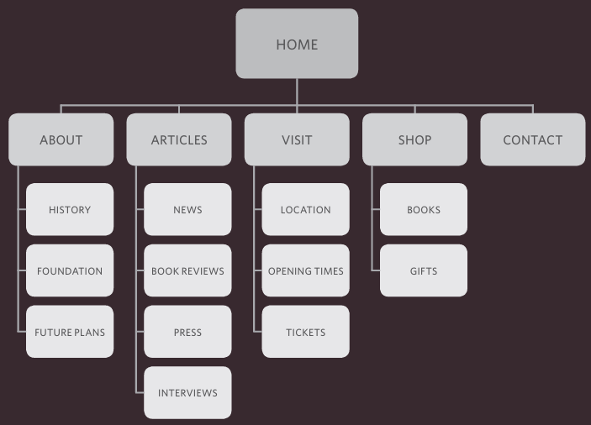

-Wireframes: a simple sketch of the key information that needs to go on each page of a site. It shows the hierarchy of information and how much space it might require. You should not include the color scheme, font choices, backgrounds or images for website in wireframe. It should focus on what information needs to be on each page and create a visual hierarchy to indicate the most important parts of each page.

+You can sketch wireframes on paper or use a graphics app on computer (Illustrator or InDesign)

+Online wireframe tools: 

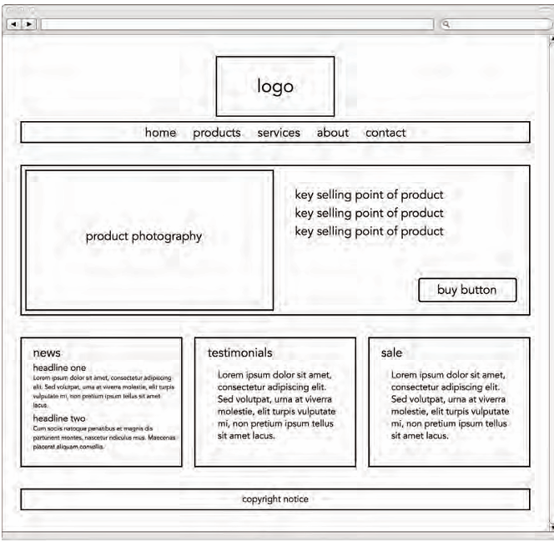

-Getting your message across using design

+The primary aim of visual design is to communicate. Organizing and prioritizing information on page helps users understand its importance and what order to read it in.

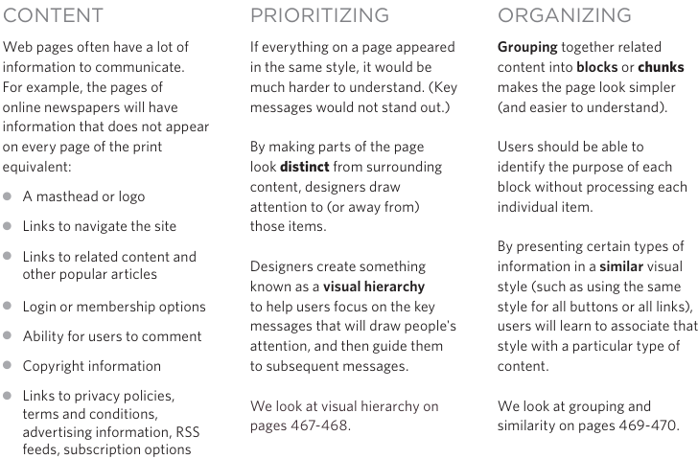

-Visual hierarchy: Across the key message and help users find what they are looking for.

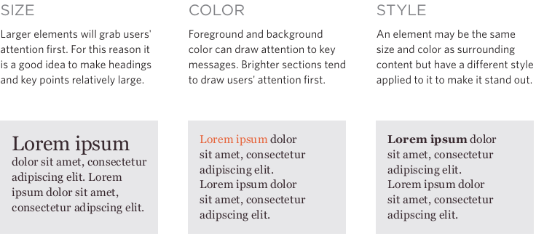

+Visual hierarchy created by adding visual contrast between items being displayed. Images create a high visual contrast and often attract the eye first.

-Grouping and similarity

+We tend to organize visual elements into groups. Grouping related pieces of information together can make design easier to comprehend

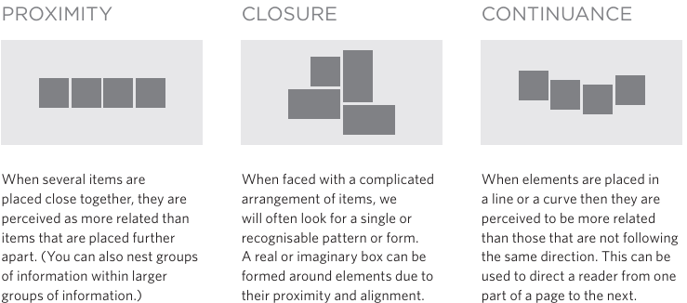

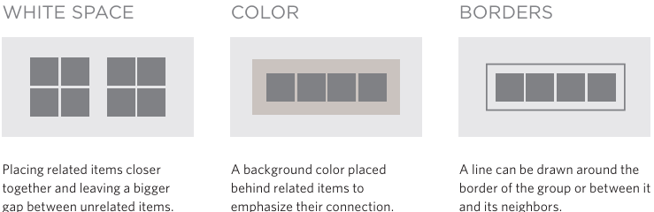

+Repetition of similar color, size, orientation, texture, font, or shape, suggests that matching elements have similar importance or meaning: consistency, headings

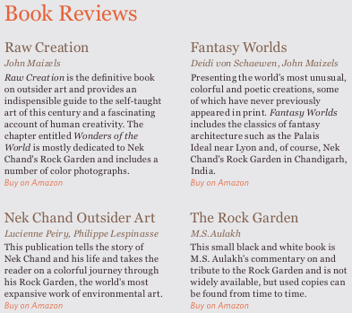

-Designing navigation

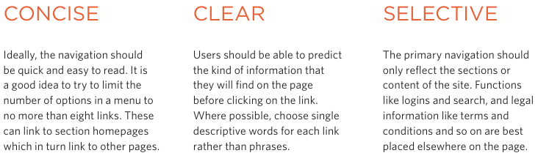

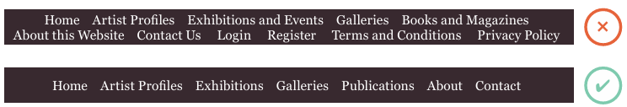

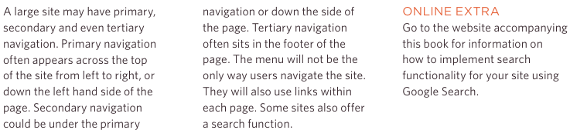

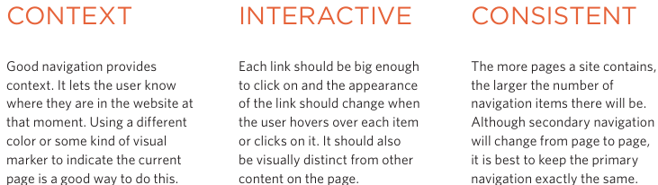

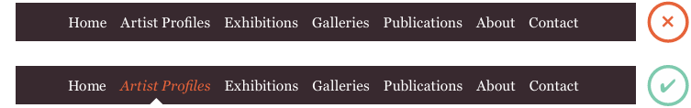

-Summary

+It's important to understand who your target audience is, why they would come to your site, what information they want to find and when they are likely to return.

+Site maps allow you to plan the structure of a site.

+Wireframes allow you to organize the information that will need to go on each page.

+Design is about communication. Visual hierarchy helps visitors understand what you are trying to tell them.

+You can differentiate between pieces of information using size, color, and style.

+You can use grouping and similarity to help simplify the information you present

# Chapter 19: Practical Information

-Search engine optimization (SEO)

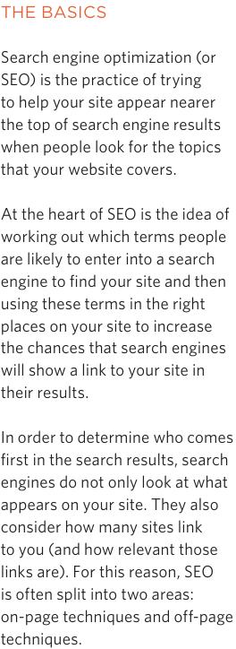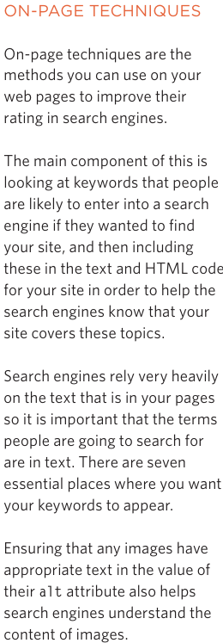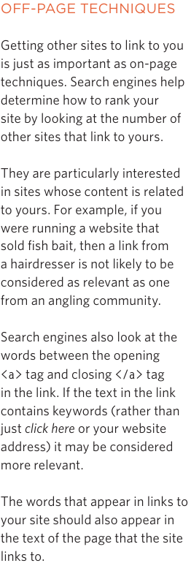

-On-page SEP

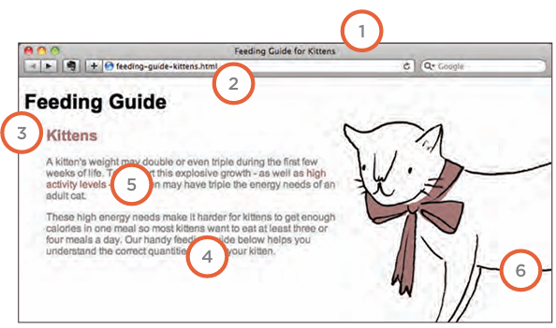

+Page title

+URL/Web address

+Headings

+Text

+Link text

+Image alt text

+Page description

-How to identify keywords and phrases

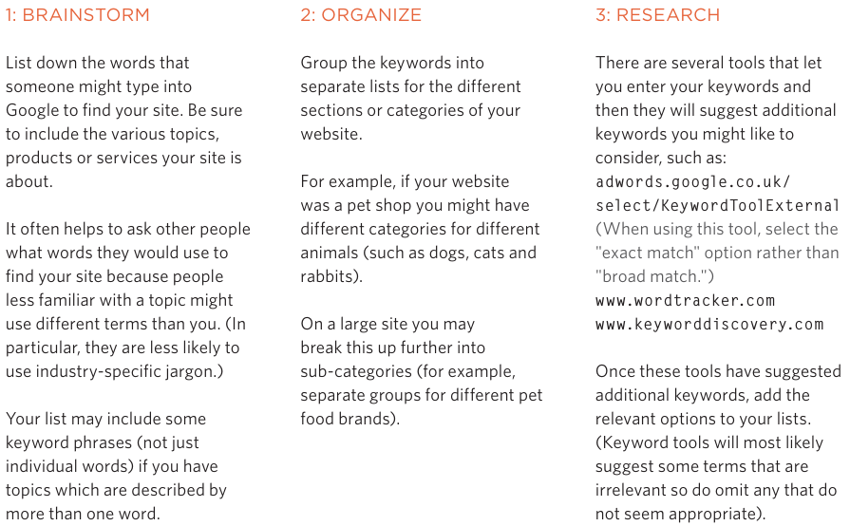

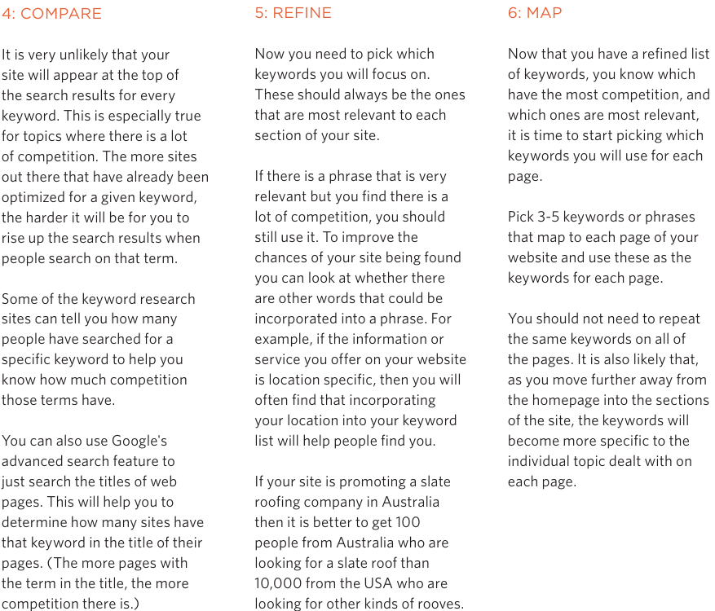

-Analytics: learning about your visitors

+You can start analyzing how they found it, what they were looking at and at what point they are leaving. One of best tools for doing this is a free service offered by Google called Google Analytics

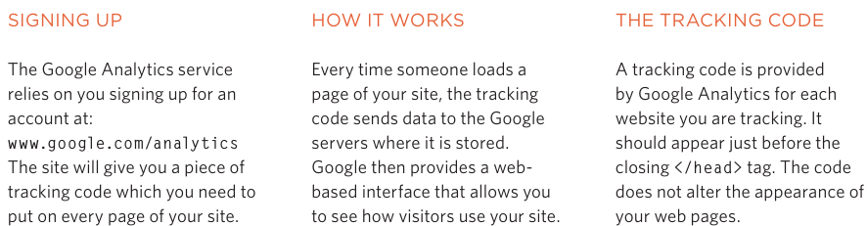

-How many people are coming to your site: 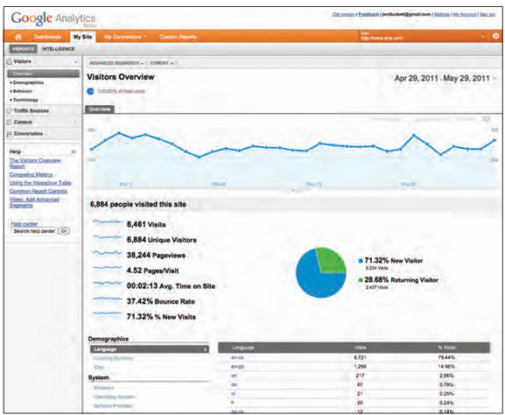

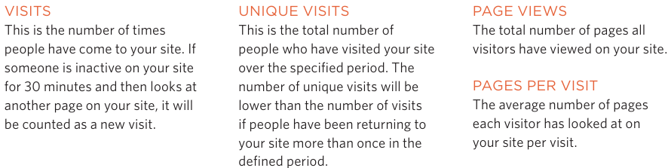

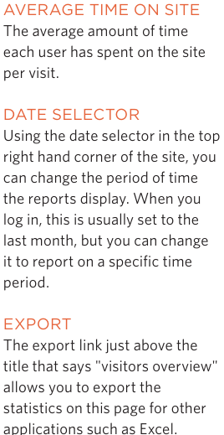

-What are your visitors looking at?

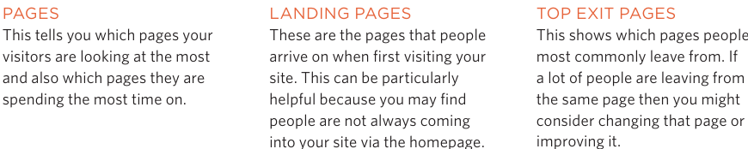

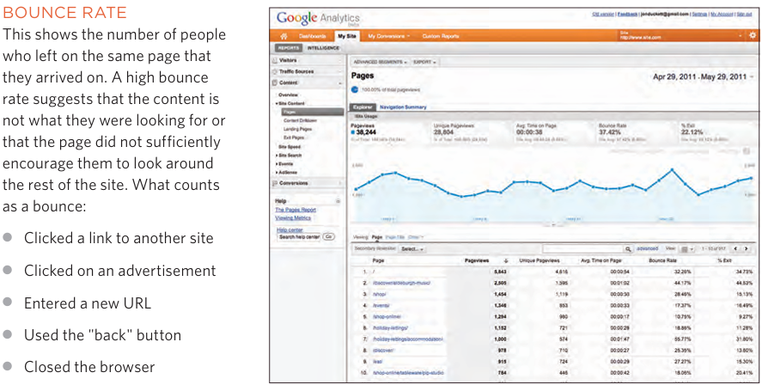

-Where are your visitors coming from?

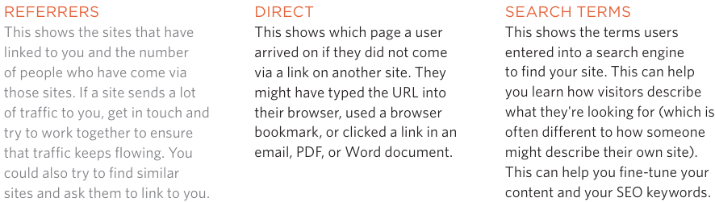

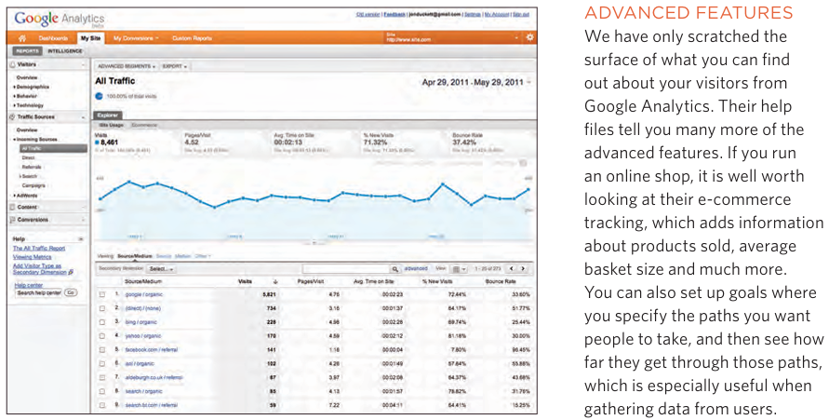

-Domain names & hosting

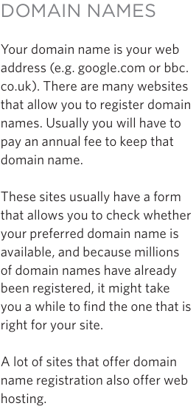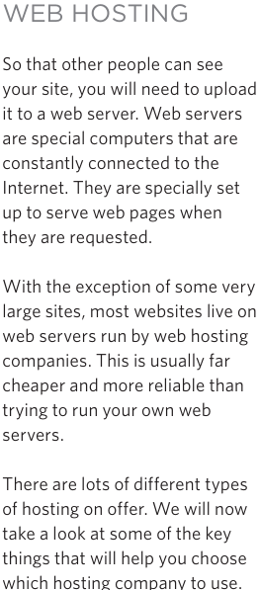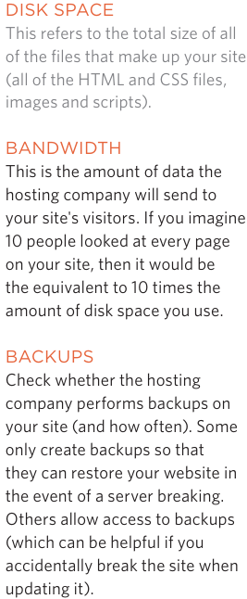

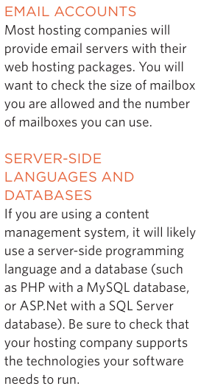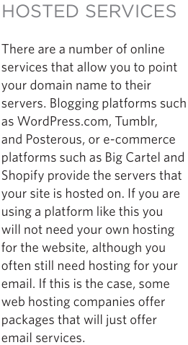

-FTP & Third party tools:

+To transfer code and images from your computer to hosting company, use File Transfer Protocol

+There are many FTP programs offering simple interface that shows you the files on your computer alongside the files that are on your web server. These allow you to drag and drop files from your computer to server or vice versa

+There are a wide variety of sites that offer services commonly created by web developers (to save you having to build them yourself)

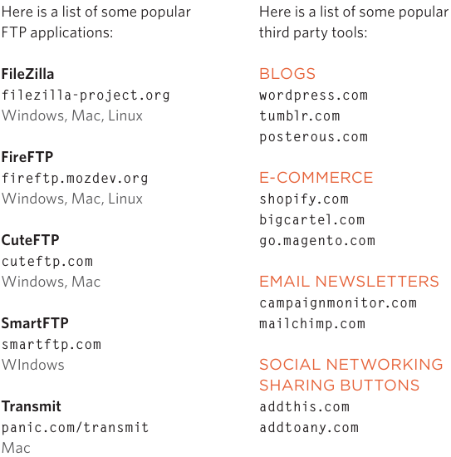

-Summary:

+SEO helps visitors find your sites when using SE

+Analytics tools such as Google Analytics allow yout to see how many people visit your site, how they find it, and what they do when they get there

+To put your site on web, you need to obtain domain name and web hosting

+FTP programs allow to transfer files from your local computer to web server

+Many companies provide platform for blogging, email newsletters, e-commerce and other popular website tools (save you writing them from scratch)